**DAT 205 Meeting Minutes Mar 7, 2021 at 1300hrs ET**

**Topic:** Team meeting – Project

**Participants:**

Bhavika Patil

Cindy Guo

Dennis Hung

**Discussion**

**Objective (review)**

* Improve team according player performance metrics and salaries
* Assumptions
  + Use Toronto Raptors 2019-20 season / players as a baseline to see what are the team’s weak or strong features. This could be used as the training data
  + Use 2020-21 season as the test data

NBA data

* Status
  + NBA_API Endpoint (PlayByPlay) can be pulled for at a game based on game_id
    - Pull for multiple games
  + Player salary data is being obtained. Pull for 2015 to 2022
  + (Completed) NBA_API Endpoint (PlayerGameLogs) can pull all games (Pre Season / Regular / Playoffs) for each game/player.
* Next steps
  + Separating the data into tables for indexing and reduce data duplication
  + Separate data into tables

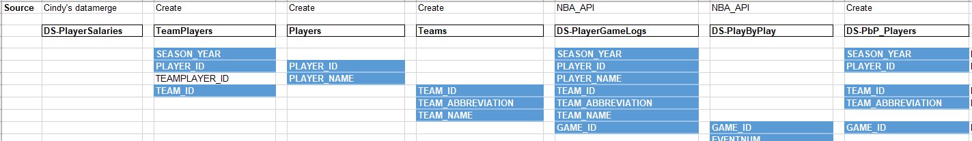

GitHub Repository

* GitHub will be the repository for versioning and data storage as much as possible reducing how we work with Google Drive.

Salary Data (Updated Reference Useful URLs.docx)

* ESPN - NBA Player Salaries
  + <http://www.espn.com/nba/salaries>
* NBA Player Salaries | HoopsHype
  + <https://hoopshype.com/salaries/players/>
* NBA Player Contracts
  + <https://www.basketball-reference.com/contracts/players.html>
* Note:
  + The salary cap for the 2020-21 NBA season is projected to rise to $115 million
    - <https://bleacherreport.com/articles/2873875-report-updated-2020-21-nba-salary-cap-luxury-tax-projections-revealed#:~:text=The%20salary%20cap%20for%20the,initial%20projection%20of%20%24116%20million>.
  + Toronto Raptor salary cap
    - <https://www.spotrac.com/nba/toronto-raptors/cap/>

**Action Item**

All

* Read up on
  + Advance NBA metrics
    - <https://bleacherreport.com/articles/1813902-advanced-nba-stats-for-dummies-how-to-understand-the-new-hoops-math>
  + glossary/terms used in basketball
    - <https://www.nba.com/stats/help/glossary/>

Bhavika

* Bhavika to setup GitHub account and user permissions
* Migrate some Google Drive data to GitHub (if ready)
* PlayByPlay data
  + Pull for multiple games

Cindy

* Merging salary as 1 dataset for all active players 2015 to 2022
* Setup GitHub account (non-McMaster account) and let Bhavika know

Dennis

* How to handle/calculation player performance metrics
* PlayByPlay data
  + Pull for multiple games
  + Separate to play/team metrics
* Setup GitHub account (non-McMaster account) and let Bhavika know